Chapter 1
Introduction
In today's dynamic healthcare landscape, the integration of Artificial Intelligence (AI) into healthcare systems has revolutionized the way individuals perceive and access medical information. The Healthcase Bot System represents a pioneering leap in this domain, amalgamating Python Django's robust framework with an array of AI-driven services to establish a comprehensive and user-centric platform for healthcare interactions.
At its core, the Healthcase Bot System aims to bridge the gap between healthcare providers and users, offering an intelligent, responsive, and personalized interface for addressing diverse health-related inquiries. Leveraging the power of AI, this system boasts multifaceted functionalities, including age assessment algorithms that accurately determine age-based health parameters, BMI (Body Mass Index) calculations for personalized health evaluations, and an extensive FAQ repository intelligently designed to provide precise and informative responses to commonly posed health queries.
The centerpiece of this system is an interactive chatbot, meticulously crafted to engage users in natural language conversations, offering real-time assistance, guidance, and information dissemination. This chatbot harnesses natural language processing (NLP) algorithms, machine learning models, and contextual understanding to deliver tailored responses, thereby enhancing user experience and fostering a sense of trust and reliability.
Furthermore, the integration of mapping services within the Healthcase Bot System extends its functionality beyond mere information provision. Users can seamlessly locate nearby hospitals, clinics, or healthcare facilities based on their geographical location, ensuring swift access to medical assistance in times of need.
This innovative confluence of technologies not only redefines the conventional healthcare paradigm but also empowers individuals to take proactive measures towards their well-being. By providing a user-friendly, accessible, and intelligent interface, the Healthcase Bot System endeavors to democratize healthcare information and services, fostering a healthier and more informed society.
Through continuous refinement and advancements in AI, Python Django integration, and user experience design, this system aspires to set new benchmarks in healthcare accessibility and redefine the dynamics of patient-provider interactions

Chapter 2
Literature Review
2.1 Literature Summary
Mohammed Juned, Farhat Dalvi, Janhavi Kadam, Awais Khalifey, Sakshi Mane, Shaikh Mohd Ashfaque Long IEEE AI Healthcare Chatbot is proposed under the connected healthcare framework. The project is developed for the user to save the user their time in consulting the doctors or experts for the healthcare solution [1].
Aishwarya Kedar, Jyoti Dahale, Khushboo Patel, Shivani Lahamage (IEEE Member) Chatbot System for Healthcare using Artificial Intelligence In this study, It determined that the modern chatbots perform at a very high standard to provide a reliable response to users compared to the traditional chatbots. Unlike existing chatbots which focused on various domains of healthcare. This is the best solution for people who are busy with their job schedules [2].
Vigneshwara C, Kunda Suchitra, Sareddy Nikhil Reddy, Rahul Manojkumar Makadiya IEEE they investigate a there are many algorithms which can be utilized for the chatbot, but it depends on what functions and needs we have and how we are going to design it [3].
Lekha Athota Student, Bachelor of Science Information Technology Amity University, Dubai, UAE lekhaA@amitydubai.ae Vinod Kumar Shukla Department of Engineering and Architecture Amity University, Dubai, UAE vshukla@amityuniversity.ae Nitin Pandey Amity Institute of Information Technology, Amity University Noida, UP, India npandey@amity.edu Ajay Rana AIIT, Amity University Uttar Pradesh Noida, India ajay_rana@amity.edu IEEE in this article, Here the studies are based on to recognize emotions classification using AI methods. The studies train emotions classification models from a lot of labelled data based on recurrent neural network (RNN), deep learning, and convolutional neural network. Linguistic interaction is most important in counselling using Natural Language Processing (NLP) and Natural-language generation (NLG) to understand dialogues of users. Here the multi-modal approach is used of emotion-recognition. They have collected corpuses to learn semantic information of words and represent as vector using the word vector, synonym knowledge of lexical are collected [4].

Chapter 3
Problem Statement
  - Problem Definition
The modern healthcare landscape faces a myriad of challenges, including limited accessibility to pertinent health information, inefficient communication channels between individuals and healthcare services, and a lack of personalized guidance for health-related queries. In response to these challenges, the objective of the Healthcase Bot System emerges as a solution-driven platform aimed at addressing the following critical issues:
- Health Information Accessibility: A significant problem persists in accessing accurate and timely health information. Many individuals encounter difficulties in obtaining reliable health-related guidance, leading to misinformation and confusion. The Healthcase Bot System endeavors to centralize and disseminate verified health information through an interactive chatbot interface, ensuring convenient access to accurate medical insights.
- Communication Gaps in Healthcare: The communication channels between healthcare providers and users often lack efficiency and immediacy, leading to delays in seeking necessary medical advice or assistance. This system seeks to bridge this gap by providing a responsive and intelligent chatbot capable of interpreting user queries and offering relevant and timely information, thereby facilitating swift communication and guidance.
- Personalized Health Assistance: Many individuals struggle to access personalized health assessments or guidance tailored to their specific needs. The Healthcase Bot System aims to provide personalized health assessments such as age-based health parameters and BMI calculations, catering to individual health concerns and empowering users to make informed decisions about their well-being.
- Accessibility to Immediate Medical Assistance: Locating nearby hospitals or healthcare facilities during emergencies or when in need of immediate medical attention can be challenging. Integrating mapping services within the Healthcase Bot System seeks to provide users with real-time information on the nearest medical facilities based on their location, ensuring quick access to healthcare services.
By addressing these pressing issues through the integration of Python Django's framework and AI-driven services, the Healthcase Bot System aims to revolutionize healthcare accessibility, improve communication channels, offer personalized guidance, and ensure timely access to medical assistance. Ultimately, the system aspires to empower individuals in managing their health proactively and foster a more informed and healthier society.

  - Objective
The objective of this project is,
- Accessible Information Hub: Establish a user-friendly interface providing immediate access to verified and comprehensive health information.
- Efficient Communication: Develop a responsive chatbot interface using NLP algorithms to enable seamless, natural language-based interaction for users seeking health-related guidance.
- Personalized Health Insights: Offer tailored health assessments, including age-based health parameters and BMI calculations, for personalized health evaluations.
- Geolocation Integration: Enable users to locate nearby healthcare facilities swiftly and accurately in times of need through integrated mapping services.
- Continuous Improvement: Implement machine learning algorithms to refine the chatbot's capabilities, ensuring ongoing enhancement of responsiveness and accuracy.
- Data Security Measures: Enforce robust security protocols to safeguard user information and uphold privacy standards.
- Modular Design for Scalability: Develop a system with adaptable architecture to accommodate future advancements and seamless integration of new healthcare services.
- Health Awareness Promotion: Curate and update a comprehensive FAQ repository, collaborating with healthcare professionals to promote health literacy among users.
- Performance Evaluation: Establish metrics for evaluating system performance, including user engagement, response accuracy, and satisfaction ratings.
- Empowerment through Information: Empower individuals by providing accessible, reliable, and personalized health information, encouraging proactive health management.

  - Scope
As technology continues to advance, the potential for healthcare chatbots and AI is limitless. By analyzing large amounts of data, healthcare chatbots and AI can predict potential health issues before they even occur. This can lead to earlier interventions and ultimately better health outcomes for patients.

Chapter 4
Methodology
4.1 System Model
Figure demonstrates how the proposed system works. The description of the system is as
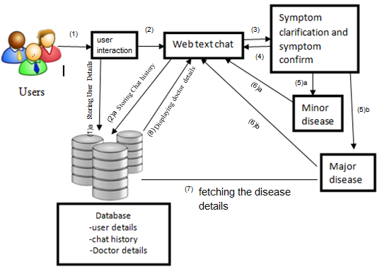
Fig. 4.1 Block diagram of system

  - User Interface: The system features a user-friendly interface accessible via web or mobile platforms, providing a seamless experience for individuals seeking health-related information and assistance.
  - Chatbot Core: At the system's heart lies an AI-powered chatbot equipped with natural language processing (NLP) algorithms and machine learning models. This core functionality interprets user queries, retrieves information from databases, and delivers tailored responses in real time.
  - AI Services Integration: The system integrates various AI-driven services such as age assessment algorithms, BMI calculators, and FAQ repositories. These services work in tandem with the chatbot to offer personalized health evaluations and reliable information to users.
  - Mapping Integration: Incorporation of mapping services allows users to locate nearby hospitals, clinics, or healthcare facilities based on their geolocation data, ensuring immediate access to medical assistance when required.
  - Backend Services: A robust backend infrastructure supports the system's functionalities, including databases for storing health information, user profiles, and FAQs. It manages data processing, ensures system stability, and supports scalability.
  - Security Protocols: The system prioritizes data security and privacy by implementing encryption methods, user authentication mechanisms, and compliance with healthcare data protection standards.
  - Continuous Improvement Mechanisms: Machine learning algorithms continuously analyze user interactions and feedback to enhance the chatbot's accuracy, responsiveness, and the overall user experience.
  - API Integration: The system is designed to integrate with external APIs for accessing updated medical information, collaborating with healthcare institutions, and ensuring the system's adaptability to future advancements in healthcare technology.
  - Monitoring and Analytics: Tools for monitoring system performance, user engagement metrics, and analytics provide insights for system enhancements and improvements.
  - Scalability and Adaptability: The system architecture is designed to accommodate future expansions, enabling seamless integration of new AI capabilities, additional healthcare services, and technological innovations

4.2 Module Descriptions
    - User Interface Module: This module encompasses the front-end development, offering an intuitive and accessible interface for users to interact with the system. It includes web and mobile interfaces designed for ease of navigation and engagement.
    - Chatbot Core Module: At the system's core, this module houses the chatbot functionality. It incorporates natural language processing (NLP) algorithms, machine learning models, and conversational logic, enabling the chatbot to interpret user queries, retrieve information from databases, and provide accurate responses in real time.
    - AI Services Integration Module: This module integrates various AI-driven services such as age assessment, BMI calculation, and FAQ interpretation. It ensures seamless communication between the chatbot and these services, enabling personalized health evaluations and precise information delivery.
    - Mapping Integration Module: This module integrates mapping services, allowing users to access geolocation-based information to locate nearby hospitals, clinics, or healthcare facilities. It interacts with mapping APIs to provide users with real-time location-based assistance.
    - Backend Services Module: Backend functionalities include databases for storing user profiles, health information, FAQs, and system configurations. It manages data processing, system stability, and supports the functionalities of the front-end modules.
    - Security and Privacy Module: Focused on safeguarding user data, this module implements encryption methods, user authentication mechanisms, and compliance measures with healthcare data protection standards to ensure data security and privacy.
    - Continuous Improvement Module: This module utilizes machine learning algorithms to analyze user interactions, feedback, and system performance. It facilitates continuous enhancement of the chatbot's accuracy, responsiveness, and overall user experience.
    - API Integration Module: This module facilitates integration with external APIs for accessing updated medical information, collaborating with healthcare institutions, and ensuring adaptability to evolving healthcare technologies.
    - Monitoring and Analytics Module: Responsible for monitoring system performance, user engagement metrics, and analytics, this module provides insights for system enhancements, improvements, and future planning.
    - Scalability and Adaptability Module: Focused on the system's architecture, this module ensures scalability and adaptability to accommodate future expansions, additional healthcare services, and technological advancements without compromising system integrity or performance.

Chapter 5
DFD Diagrams
A data flow diagram (DFD) is a nothing but a graphical representation of the ”flow” of data through an information system, which is used for modelling its Process aspects. Mostly DFD’s are very preliminary step which is used for representing overview of system which can later explain in detail. DFDs can also be used for the visualization of data processing (structured design). A DFD shows what kind of information will be input to and output from the system, where the data will come from and go to, and where the data will be stored. It does not show information about the timing of processes, or information about whether processes will operate in sequence or in parallel.

  - Level 0 DFD

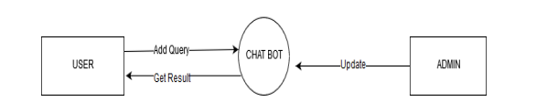
Fig. 5.1 Data Flow Diagram Level 0

  - Level 1 DFD

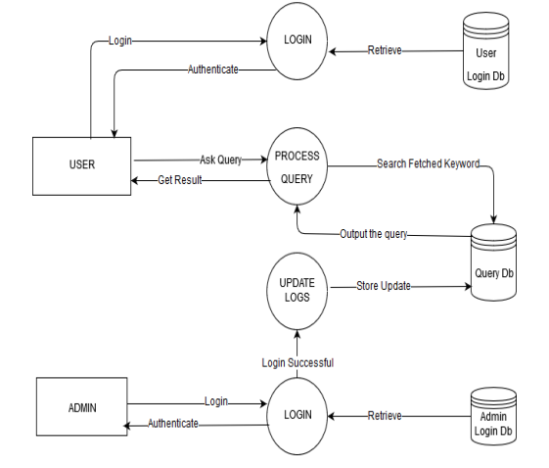
Fig. 5.2 Data Flow Diagram Level 1

Chapter 6
UML Diagrams
The Unified Modeling language is the Standard visual modeling language intended to be used for modeling business and similar process ,analysis ,design, and implementation of software based system.
Goals of UML
There are number of goals for developing UML but the most important is to define some general purpose modeling language which all modelers can use and also it needs to be made simple to understand and use. UML diagram are not only made for developers but also for business users ,common people and anybody interested to understand the system. The system can be a software and non software .
At the conclusion the goal of UML can be defined as a simple modeling mechanism to model all possible practical system in today's complex environment. UML diagrams are the ultimate output of the entire discussion. All the elements, relationships are used to make a complete UML diagram and the diagram represents a system.
The visual effect of the UML diagram is the most important part of the entire process. All the other elements are used to make it complete one. UML includes the following diagram :
- Use case diagram
- Class diagram
- Object diagram
- Sequence diagram
- Activity diagram
- State chart diagram
- Collaboration diagram
- Deployment diagram
- Component diagram
6.1 Use Case Diagram
Use Case diagrams identify the functionality provided by the system (use cases), the users who interact with the system (actors), and the association between the users and the functionality.Use Cases are used in the Analysis phase of software development to articulate thehigh-level requirements of the system.
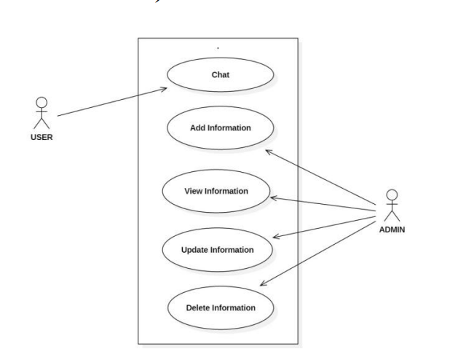

Fig. 6.1 Use Case Diagram

6.2 Class Diagram
Class diagrams are the most common diagrams used in the UML. Class diagram consist of classes , interfaces ,associations and collaboration. It basically represents the object oriented view of system which is static in nature. It represents the object orientation of system. So it is generally use for development purpose. This is the most widely used diagram at the time of system construction.
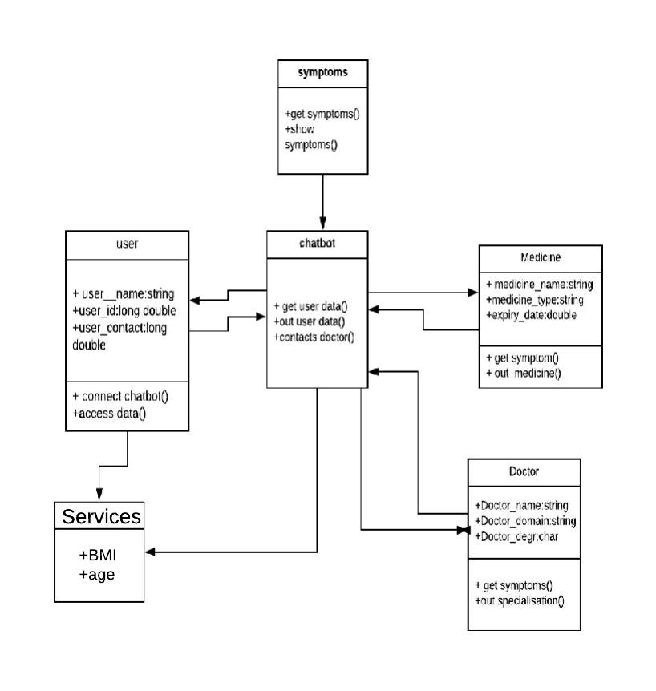
Fig. 6.2 Class Diagram

6.3 Sequence Diagram
Sequence diagrams in UML shows how object interact with each other and the order those interactions occur. It’s important to note that they show the interactions for a particular scenario. The processes are represented vertically and interactions are show as arrows.A sequence diagram shows object interactions arranged in timely sequence. It depicts the objects and classes involved in the scenario and the sequence of messages exchanged between the objects needed to carry out the functionality of the scenario.

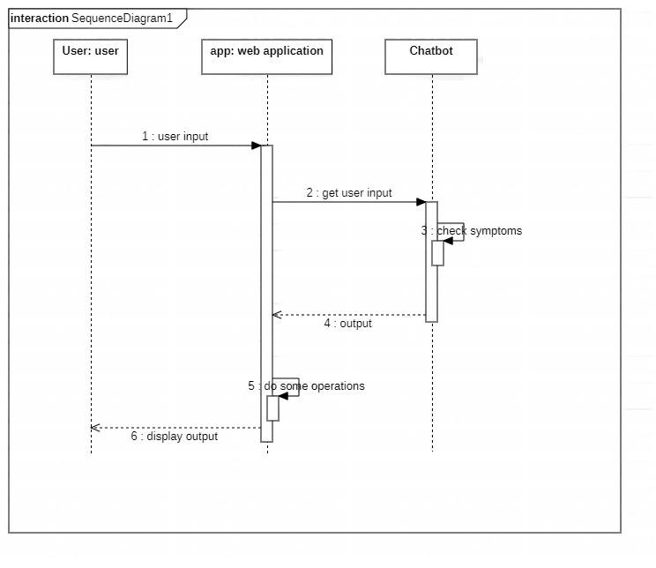
Fig. 6.3 Sequence Diagram

6.4 Activity Diagram
Activity diagrams describe the work behavior of a system. Activity diagrams are similar to state diagrams because activities are the state of doing something. The diagrams describe the state of activities by showing the sequence of activities performed. Activity diagrams can show activities that are conditional or parallel. In general Activity diagrams is used to show different activities which are performed by the system. Following figure shows different activities.
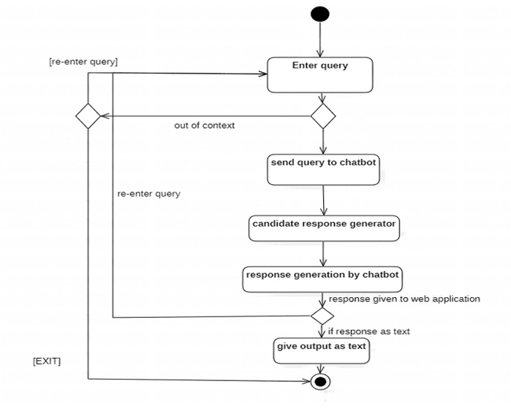
Fig. 6.4 Activity Diagram

Chapter 7
Coding Demo
7.1 Snapshot:

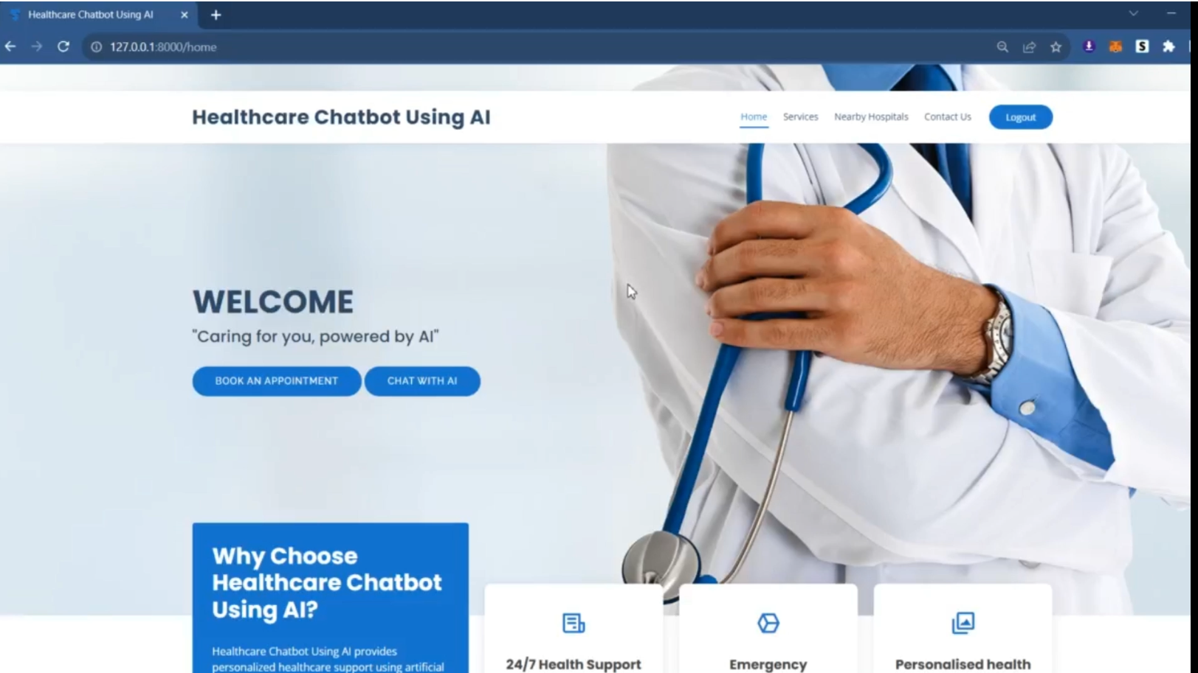

Fig 7.1 Homepage
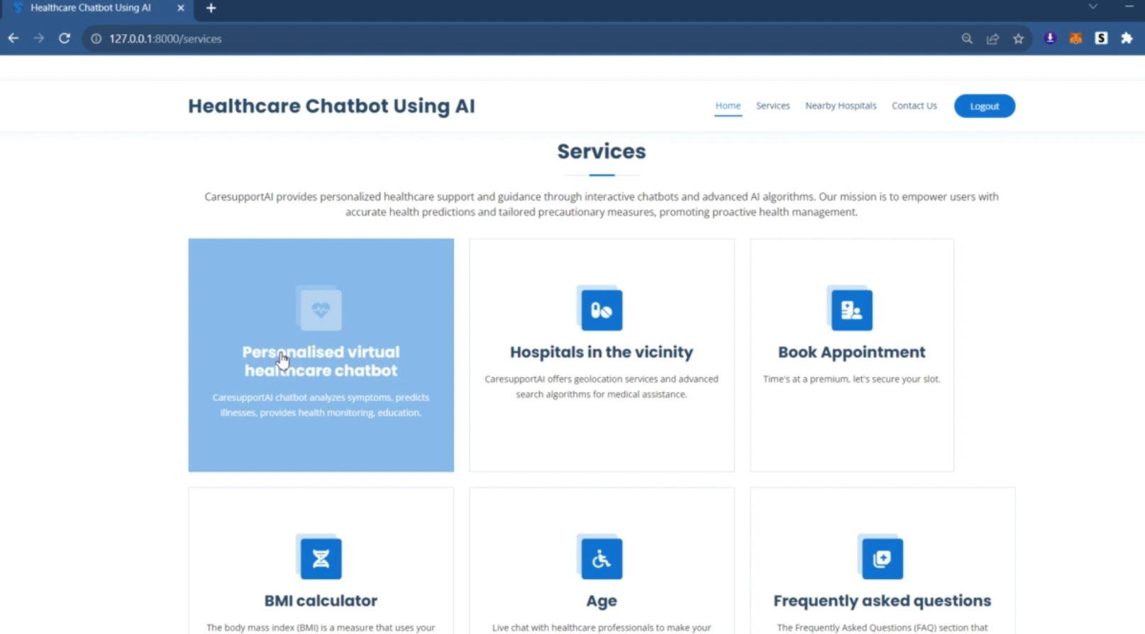

Fig. 7.2 Services

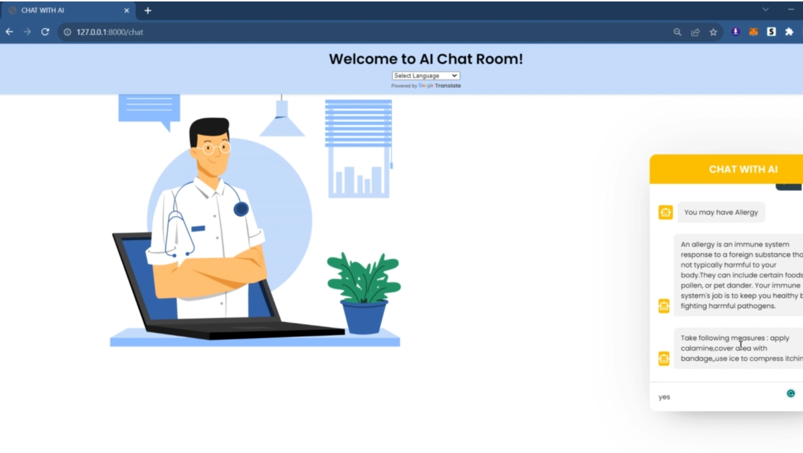
Fig. 7.2 Chatbot

Chapter 8
Conclusion
In conclusion, the development and integration of the Healthcase Bot System mark a significant stride towards revolutionizing healthcare accessibility and interaction. By amalgamating Python Django's robust framework with a spectrum of AI-driven services, this system redefines the way individuals access, interpret, and engage with health-related information. The creation of a user-centric interface and the implementation of an AI-powered chatbot lay the foundation for an intuitive and interactive platform, offering immediate access to accurate health information and personalized assistance. The integration of age assessment algorithms, BMI calculations, FAQ interpretation, and mapping services empowers users with tailored health evaluations, immediate guidance, and access to nearby healthcare facilities based on their geographical location. Moreover, the system's modular architecture ensures scalability, adaptability to future advancements, and seamless integration with evolving healthcare technologies. The continuous improvement mechanisms, including machine learning algorithms and monitoring tools, guarantee ongoing enhancements to the chatbot's responsiveness, accuracy, and user experience. As the healthcare landscape evolves, the Healthcase Bot System stands as a beacon of innovation, striving to bridge communication gaps, promote health literacy, and empower individuals in managing their well-being proactively. With a commitment to data security, user privacy, and a relentless pursuit of excellence, this system aims to foster a more informed, engaged, and healthier society.
In essence, the Healthcase Bot System encapsulates a vision of healthcare democratization, leveraging technology to transcend boundaries and place invaluable health-related insights at users' fingertips. Through a cohesive integration of AI, user-centric design, and technological prowess, this project underscores the potential to reshape the future of healthcare interaction and empowerment

References
- Hiba Hussain1, Komal Aswani2, Mahima Gupta3, Dr. G.T.Thampi4,”Implementation of Disease Prediction Chatbot and Report Analyzer using the Concepts of NLP, Machine Learning and OCR,”IRJET,Apr 2020.
- Kowatsch, T., M. Nißen, C.-H. I. Shih, D. Rüegger, D. Volland, A. Filler, F. Künzler, F. Barata, D. Büchter, B. Brogle, et al. (2017). Text-based healthcare chatbots supporting patient and health professional teams: preliminary results of a randomized controlled trial on childhood obesity.
- Lin Ni(B), Chenhao Lu, Niu Liu, and Jiamou Liu,” MANDY: Towards a Smart Primary Care Chatbot Application”, SPRINGER,2017.
- Divya, S., V. Indumathi, S. Ishwarya, M. Priyasankari, and S. K. Devi (2018). A self-diagnosis medical chatbot using artificial intelligence. Journal of Web Development and Web Designing, 3(1), 1–7.
- Kavitha, B. and C. R. Murthy (2019). Chatbot for healthcare system using artificial intelligence.
- Kandpal, P., K. Jasnani, R. Raut, and S. Bhorge, Contextual chatbot for healthcare purposes (using deep learning). In 2020 Fourth World Conference on Smart Trends in Systems, Security and Sustainability (WorldS4). IEEE, 2020.
- A. F. Ur Rahman Khilji, S. R. Laskar, P. Pakray, R. A. Kadir, M. S. Lydia and S. Bandyopadhyay, "HealFavor: Dataset and A Prototype System for Healthcare ChatBot," 2020 International Conference on Data Science, Artificial Intelligence, and Business Analytics (DATABIA), 2020.
- HEALTHCARE CHATBOT 1Athulya N, 2 Jeeshna K, 3S J Aadithyan,4U Sreelakshmi,5Hairunizha Alias Nisha Rose College of Engineering Thalassery , India.

